# Lab 1. Introduction to modelling

**Name: Li Xin**

**ITMO ID:22320404**

## Specialization: Automation

## Objective

Familiarize yourself with the Simulink software environment and basic methods for modeling linear electrical circuits.

## Theoretical information

A mathematical model of a linear electric circuit as a linear stationary system can be represented in the form of a scalar differential equation of the *nth* order (input-output model) or in the form of a system of *n* differential equations of the 1st order (input-state-output model).

The input-output model has the form

, (1)

where *y* is the output variable, *u* is the input signal, *n* is the order of the system, *m* is the order of the derivative of the output variable, which explicitly depends on *u*   
( ), *a j* , *b j* are constant coefficients.

Provided that , the input-state-output model can be represented as

 (2)

where *x j* are the coordinates of the state vector, α *ij* and β *j* are constant coefficients. System (2) can be represented in a compact vector-matrix form

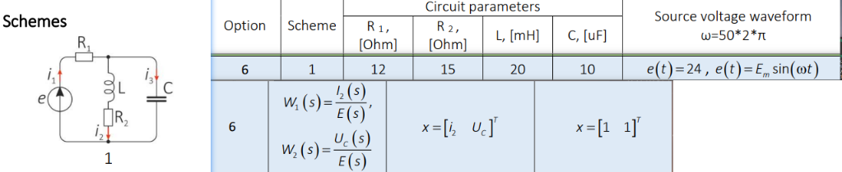

**1. Build a simulation circuit.**

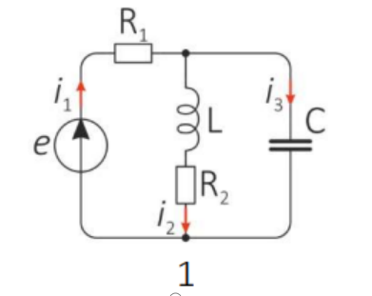

**Figure 1.** Equivalent circuit.

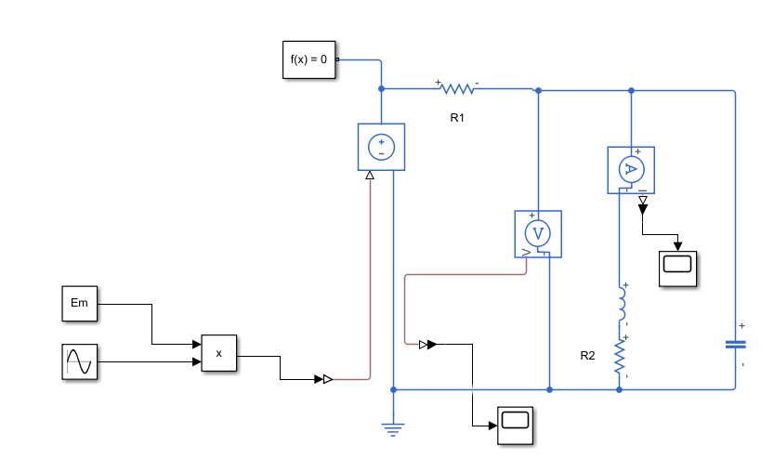**Figure 2.** Simulation circuit.

**2. Component equations.**

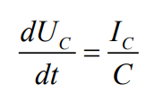

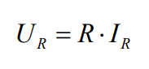

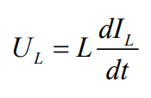

**3. Topological equations.**

 

$e\left(t\right)−u_{R1}−u_{L}−u_{R2}=0$

$$u_{L}+u_{R2}−u_{C}=0$$

$$i_{1}=i_{2}+i_{3}$$

**4. State-space model.**

$$\frac{dx_{1}}{dt}=\frac{di_{2}}{dt}, \frac{dx_{2}}{dt}=\frac{du_{C}}{dt}$$

$$e\left(t\right)=u_{R1}+u_{C}=i_{1}R_{1}+u_{C}=\left(C\frac{du_{C}}{dt}+i_{2}\right)R_{1}+u_{C}$$

$$e\left(t\right)=CR_{1}\frac{du_{C}}{dt}+i_{2}R_{1}+u_{C}$$

$$\frac{du_{C}}{dt}=\frac{e\left(t\right)+i_{2}R_{1}−u_{C}}{CR_{1}}=−\frac{1}{C}i_{2}−\frac{1}{CR_{1}}u_{C}+\frac{e\left(t\right)}{CR_{1}}$$

**Solution: $a_{12}=−\frac{1}{C}, a_{22}=−\frac{1}{CR_{1}}, b_{21}=\frac{1}{CR_{1}}$**

$$\frac{di_{2}}{dt}=\frac{u_{L}}{L}=\frac{u_{C}−i_{2}R_{2}}{L}=−\frac{R_{2}}{L}i_{2}+\frac{1}{L}u_{C}$$

Solution: $a_{11}=−\frac{R_{2}}{L}, a_{12}=\frac{1}{L}, b_{11}=0$

**5. Simulink simulation of the circuit and the state-space model using the predetermined input and zero initial conditions.**

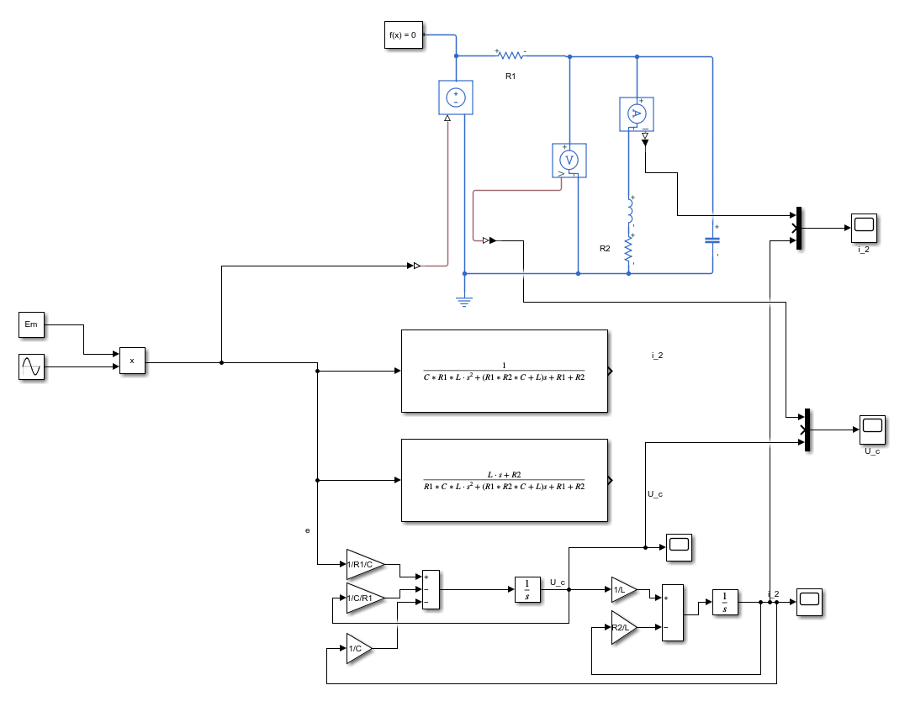

**Figure 3** Modelling with sinusoidal input voltage

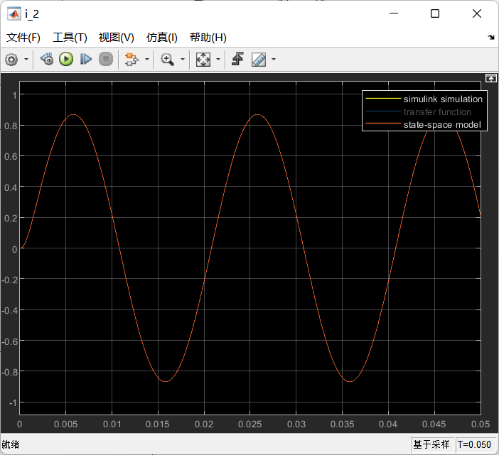

**Figure 4** i_2 of Simulink simulation of the circuit and the state-space model

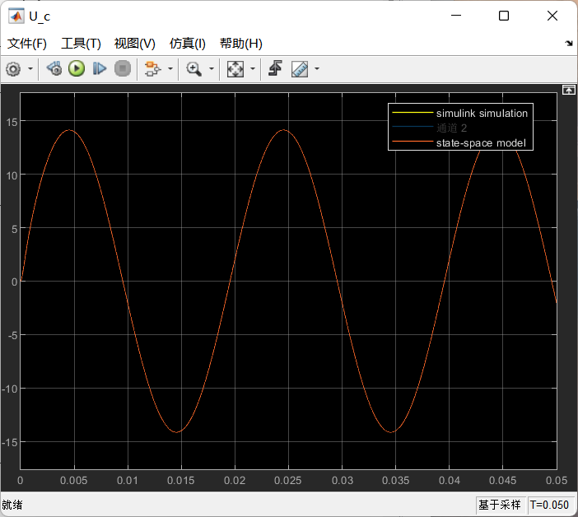

**Figure 5** U_c of Simulink simulation of the circuit and the state-space model

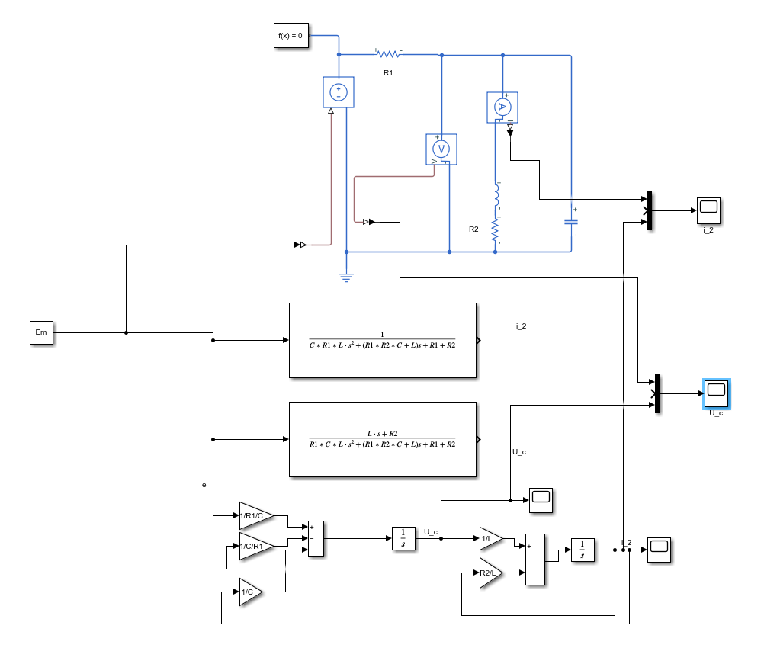

**Figure 6** Modelling with constant voltage

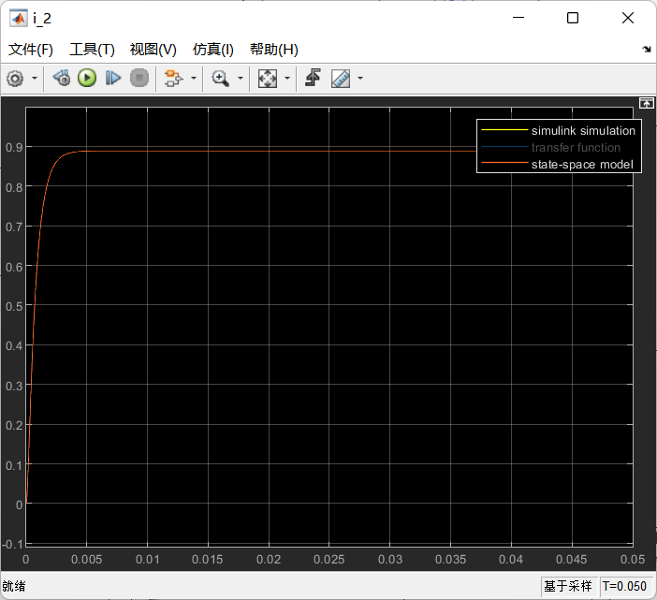

**Figure 7** i_2 of Simulink simulation of the circuit and the state-space model

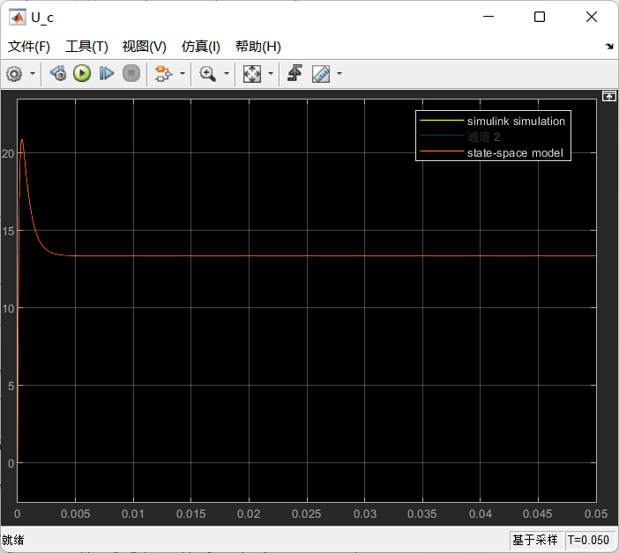

**Figure 8** U_c of Simulink simulation of the circuit and the state-space model

**6. “Input-output" model.**

$$si_{2}=\frac{U_{C}−i_{2}R_{2}}{L}$$

$$sU_{C}=−\frac{i_{2}}{C}−\frac{U_{C}}{CR_{1}}+\frac{1}{CR_{1}}e$$

$$U_{C}\left(s\right)=\frac{LS+R_{2}}{CR_{1}LS^{2}+\left(CR_{1}R_{2}+L\right)S+R_{1}+R_{2}}e\left(s\right)$$

$$i_{2}\left(s\right)=\frac{1}{CR_{1}LS^{2}+\left(CR_{1}R_{2}+L\right)S+R_{1}+R_{2}}e\left(s\right)$$

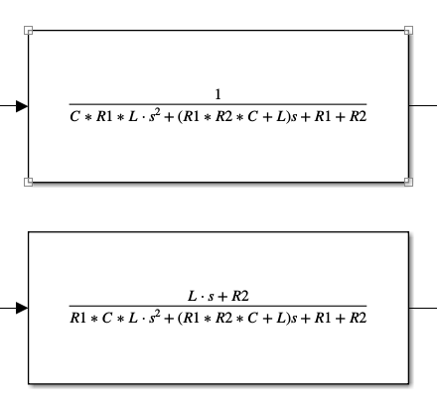

**7. Simulink simulation of the circuit and the resulting** **transfer functions using the predetermined input**

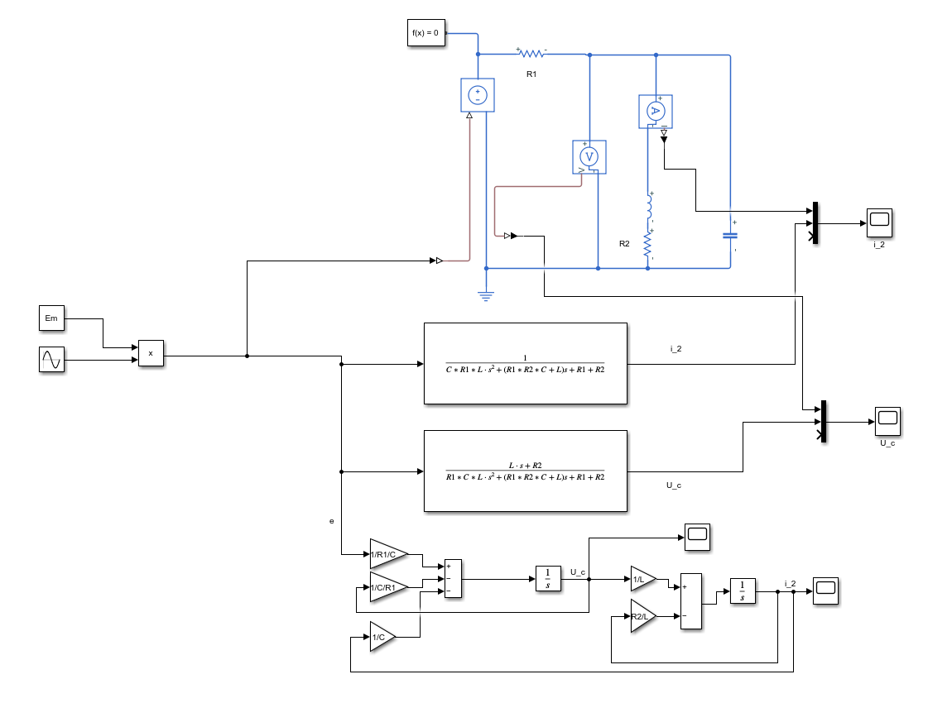

**Figure 9** Modelling with sinusoidal input voltage

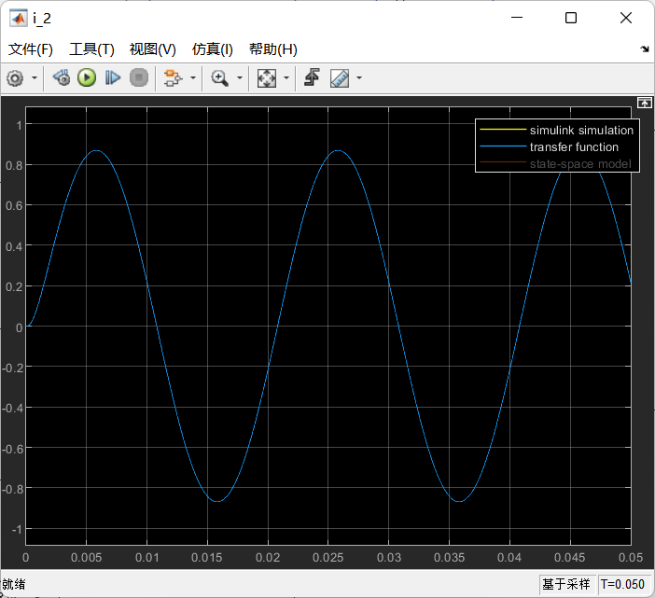

**Figure 10** i_2 of Simulink simulation of the circuit and transfer functions

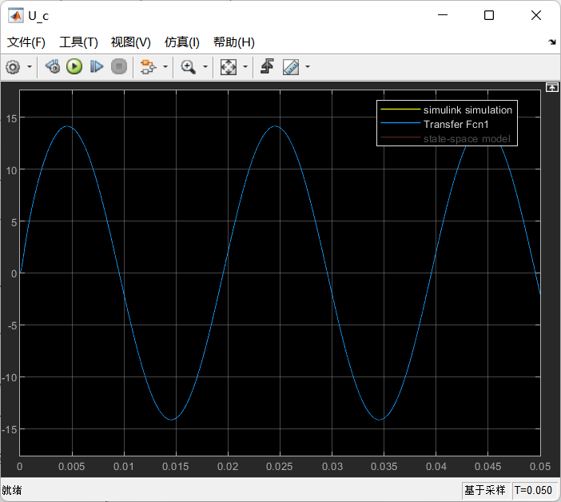

**Figure 11** U_c of Simulink simulation of the circuit and transfer functions

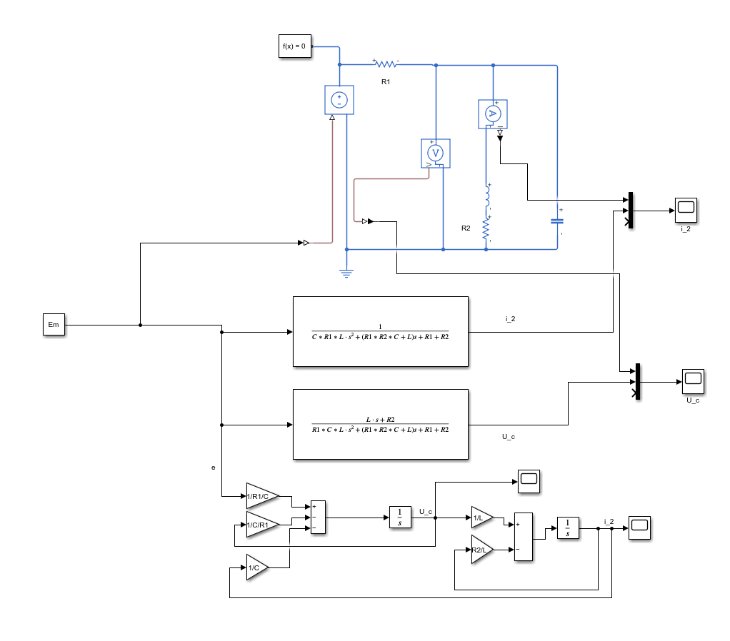

**Figure 12** Modelling with constant voltage

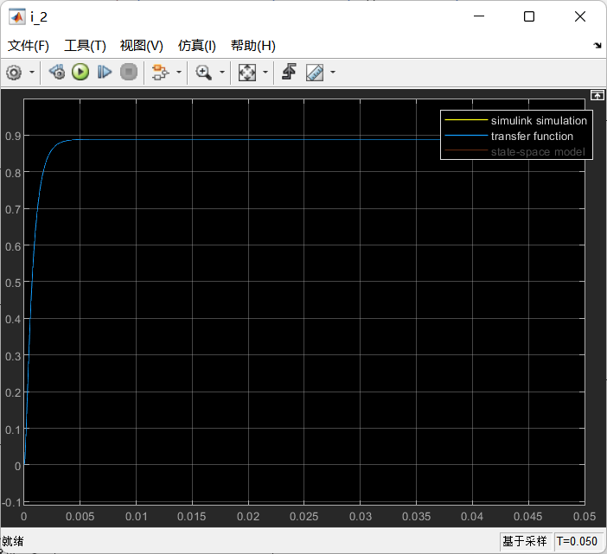

**Figure 13** i_2 of Simulink simulation of the circuit and transfer functions

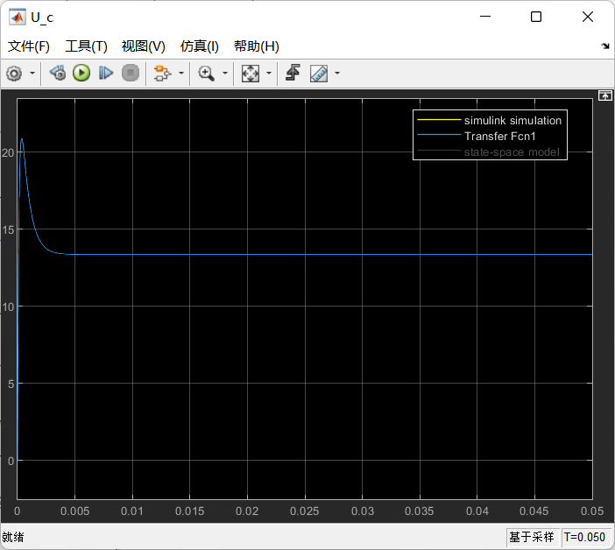

**Figure 14** U_c of Simulink simulation of the circuit and transfer functions

**8. Simulation of the circuit and the state-space model with zero input and non-zero initial conditions.**

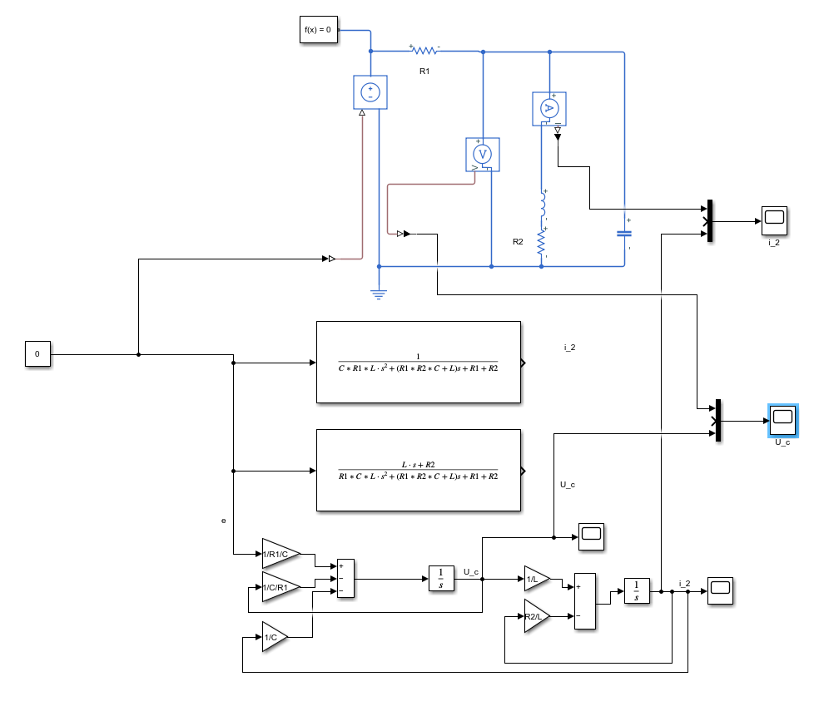

**Figure 15** Modelling with zero voltage and nonzero initial conditions

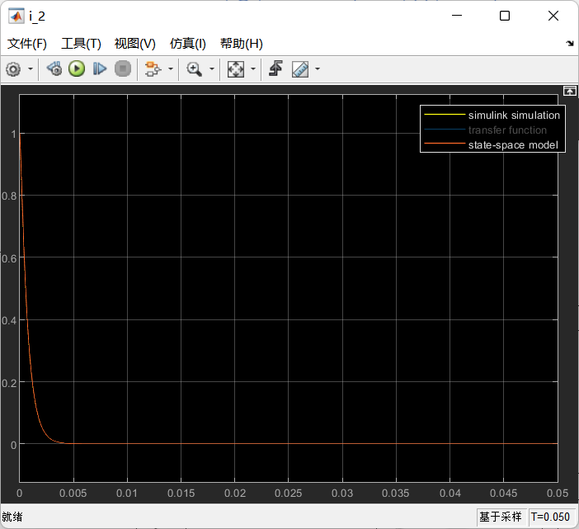

**Figure 16** i_2 of Simulink simulation of the circuit and the state-space model

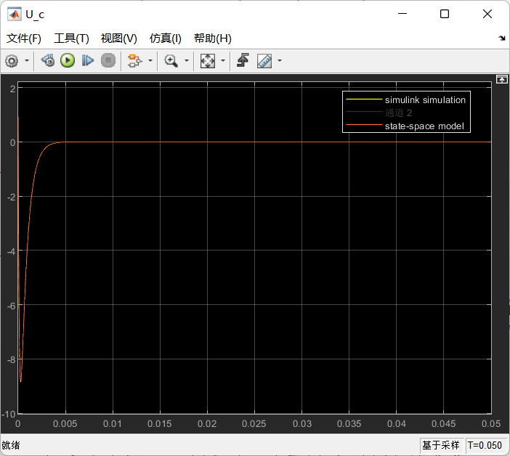

**Figure 17** U_c of Simulink simulation of the circuit and the state-space model

**Conclusions:**

In this lab, I successfully implemented and simulated a linear electrical circuit using three different modeling approaches in Simulink: **Simscape circuit, state-space representation, and transfer function.**

Through the experiments, I observed that all three models produced similar transient and steady-state responses, confirming their theoretical equivalence in circuit analysis.

And I applied different types of input signals to the circuit, including sinusoidal voltage, constant voltage, and zero input with nonzero initial conditions.For sinusoidal voltage,The circuit responded with a steady-state sinusoidal output, maintaining the same frequency as the input but with an amplitude change and a phase shift. For constant voltage,The circuit exhibited transient behavior before reaching a steady-state condition.For zero input with nonzero initial conditions,I observed the system’s natural response, which depends entirely on the circuit’s initial energy stored in capacitors and inductors.